**International Baccalaureate**

**Mathematics: Applications and Interpretations**

**Higher Level**

**Internal Assessment**

An exploration to create a mathematical model that can predict the number of sprays required to exhaust liquid and gas perfume bottles.

# **Rationale:**

Every spray of perfume feels like capturing a moment, a fusion of fragrance and elegance collated just in one touch. I personally adore perfumes and find the experience of walking into a perfume store intriguing. Being surrounded by countless number of bottles that promise a moment to be stored with every spray. Especially, the way each bottle is crafted, both in design and its mechanism, has always kept me engaged.

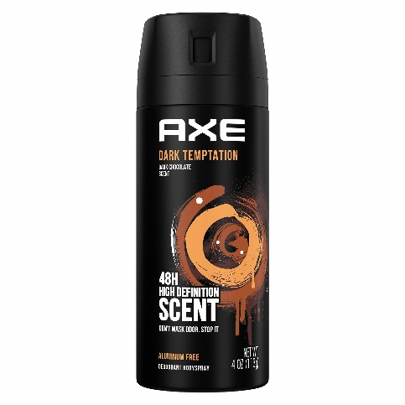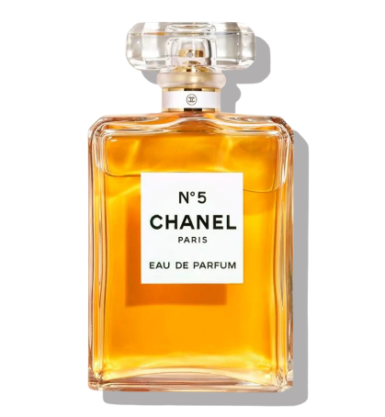I often get concerned about my perfumes getting over and lack information about how long a perfume bottle would last. The number of sprays hidden within its intricate geometry is an important information that I have never come across. For example: How does the mechanism differ for liquid perfumes like 100 ml Chanel No.5 (figure1) compared to gas-based sprays like 100 ml AXE Body Spray (figure2)? This basic thought drove me towards this exploration of mathematical principles underlying these everyday products.

**Figure1. Chanel No. 5 perfume (liquid)**

**Figure2. AXE Body spray (gas-based)**

# **Introduction:**

Perfume bottles, irrespective whether they are liquid or gas-based operate differently having distinctive longevity. The design of a perfume bottle, the mechanism of the spray nozzle, and the efficiency of the same is often overlooked by consumers like me. This exploration fully uncoils the mathematical principles that determine the longevity of perfumes by answering the research question: **“How can mathematical modeling predict the number of sprays required to exhaust liquid and gas perfume bottles?”**

As shown above the chosen products for this exploration are Chanel No. 5 (figure1) an iconic liquid perfume, and AXE Body Spray (figure2), a pressurized deodorant. Both are different in their mechanisms and content properties: Chanel No. 5 releases liquid droplets, while AXE operates using pressurized gas in the bottle. By incorporating 3D modeling, this exploration adds a visual dimension, allowing for an in-depth understanding of the relationship between bottle volume, spray mechanism and product efficiency.

In this exploration, I will firstly utilize GeoGebra and 3D modeling, I will map the geometry of the two perfume bottles: a liquid-based bottle (Figure 1) and a gas-based spray (Figure 2). I will begin by plotting points along the bottle’s front profile of the bottle, fitting appropriate functions through statistical regression (using a GDC) to create a mathematical representation of the bottles. Moreover, I will use the solids of revolution methods along with integration to calculate the exact volume of the perfume stored in each bottle. For the spray mechanics, I will record and analyze the volume released per spray using rate of change and real-life measurements. Lastly, I will use this mathematical model to predict the total number of sprays for both bottles and validate my predictions by comparing them to the experimental data This approach amalgamates mathematical modeling, 3D visualization, and real-world testing, threading theory and practical application of mathematics altogether.

# **Exploration:**

The step-by-step process of the exploration has been briefly outlined above in the introduction. The major chunk will be mathematically modeling the shapes of the perfume bottles, beginning with Chanel No.5 and then AXE body spray. Post using GeoGebra for mapping the contours of each bottle I will plot a series of points along their profiles and then the points will be used to generate a mathematical function (eg: linear, quadratic, or higher-degree polynomials) to approximate the shape of the bottle. As an exception for complex curves, pricewise function will be required to accurately and precisely represent the design in a mathematical form.

The mathematical model will liberate me to revolve the generated functions around the appropriate axes using solids of revolution for calculating the theoretical volume of the bottles. Post calculation comparing the results will ensure the accuracy of the model and will set the foundation for preceding spray-volume calculations. Through this I would also be able to quantify the geometric and aesthetic differences between the liquid perfume (figure1), often directed towards elegance, and gas spray bottle (figure2), primarily prioritizing utility.

Now from here the next basic step is to investigate the mechanics of spraying for both types of bottles. As someone deeply fascinated by perfumes and having a growing collection of them, knowing how to use them more effectively and to maximize their longevity is very significant to me. To do this, the major step was to prove through integration that the volume that is given for each bottle which is 100ml is accurate and use visual representation and 3D modelling for a better understanding. Post that calculating the per spray volume of both liquid perfume (figure 1) and aerosol body spray (figure 2) to reach a point where number of sprays to exhaust the liquid can be calculated to answer the exploration.

The goal of graphing the perfume bottles is to confirm or approximate their total volume mathematically and compare it to the stated capacity (100ml). GeoGebra is used to plot both the bottles on the graph and take out the functions of the same. This demonstrates the application of functions, solids of revolution and integration while ensuring the interplay between theoretical and actual values.

The same is done for both Chanel No.5 liquid perfume (Figure 1) and AXE aerosol body spray (Figure 2):

**Volume calculation:**

1. Liquid perfume (Figure 1):

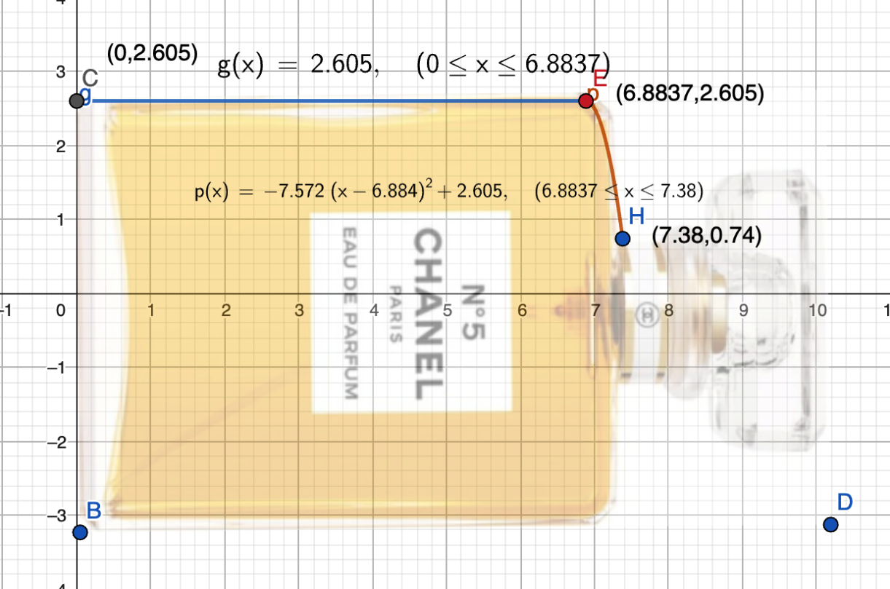

**Figure3. 2D model of Liquid perfume with Piecewise Function**

**Information on the graph:**

* **X axis:** Height of the Liquid perfume bottle
* **Y axis:** Length of the Liquid perfume bottle
* **Scale taken: 1 unit = 1 cm** (for both axis)

The liquid perfume bottle has been plotted on a cartesian plane with the piecewise function formed (Figure 3), which is the half symmetrical portion of the bottle along the x-axis, now at first will be used to find the area under the curve in order to determine and confirm the volume of the liquid perfume (Figure 1), which is 100mL. The function was derived post inserting the image of the perfume bottle on GeoGebra Classic keeping in mind the **axis of symmetry to be y=0**. The first function **g(x)=2.6005** was derived from the uniform line of **C to E** on the topmost of edge of the perfume bottle. The next two points that were taken was from **E to H forming a quadratic function**: **-7.572 (x-6.884)2+ 2.605** by taking the coordinates of the two points. The leftover part of the nozzle and the cap was eliminated from the whole investigation because it does not contribute to answering the research question as it does not contain any liquid perfume.

The area under each curve will be the value obtained after the integration of the three functions that combine to form the piecewise function. To determine the overall area of the bottle’s front face, the three area values will be added up and doubled. The final result will then be multiplied by the perfume bottle’s width to determine the possible capacity. The given value of the volume is 100mL and the same will be validated during this procedure, and the same value will be utilized in subsequent calculations. The volume calculation for liquid perfume is done below.

**Dimensions of liquid perfume:**

* **Height**: 7.38 cm
* **Length**: 5.21 cm
* **Width**: 2.60 cm

**Horizontal line Segment:**

**Parabolic segment:**

Now is the area of the half symmetrical portion of the liquid perfume bottle, to find the total area the same will be doubled and then multiplied by the width to get the volume approximately to 100mL. The 100ml volume is the ideal volume for the perfume bottle being published by the brand itself and therefore being endorsed by the same. Further process shown below:

This can approximate to , since it is a real-life product being plotted on a graph the difference in the value will exist and the exact value can never be determined therefore, approximation will play a significant role here. The final volume verifies that the volume of the liquid perfume is approximately and the same can be used to conduct calculations further.

1. 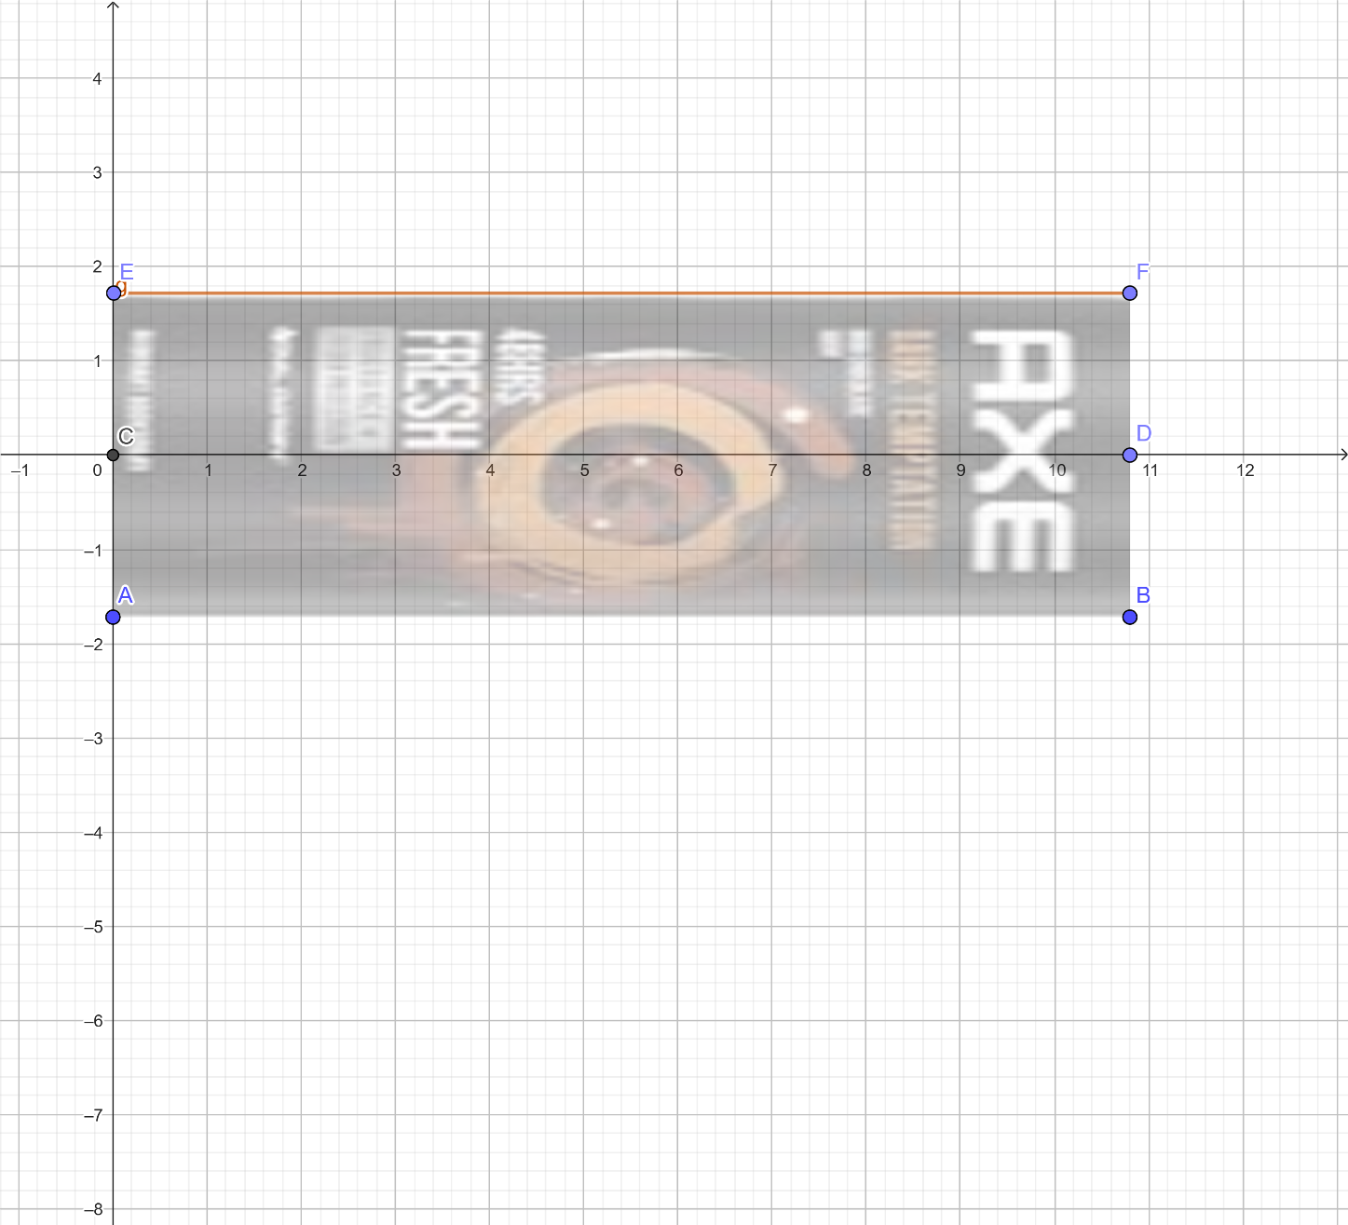**Aerosol Body spray** (Figure 2-Introduction)

**Figure4. 2D graph of AXE Aerosol body spray**

**Information on the graph:**

* **X axis:** Height of the body spray
* **Y axis:** Radius of the body spray
* **Scale taken: 1 unit = 1 cm** (for both axis)

(Solids of revolution diagram below)

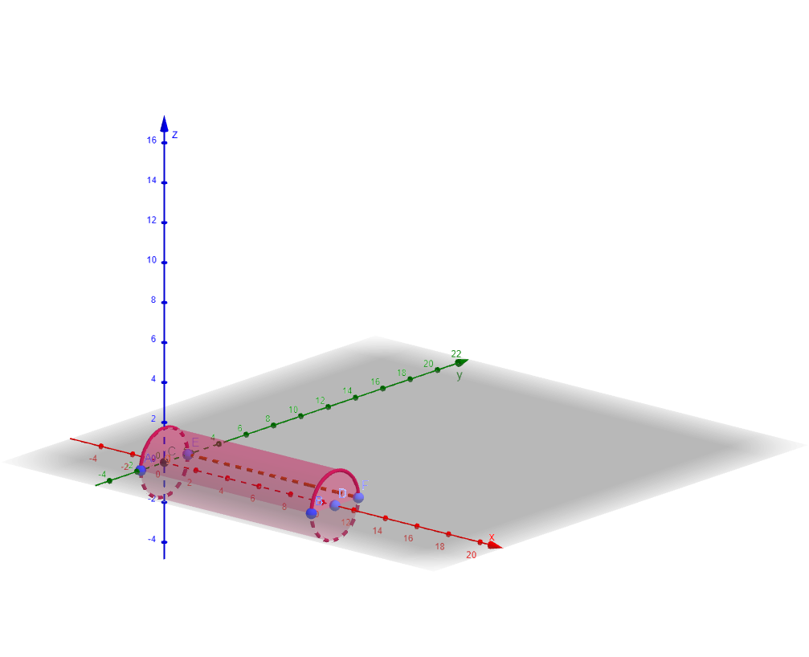

**Figure6. 3D, solids of revolution model of AXE.**

The **function y=1.72** was taken out while keeping **axis of symmetry of y=0** in mind as the same ca be seen in Figure 4, the topmost edge of the bottle from E to F is the uniform line that was considered for the same.

Now to calculate the volume of a cylinder by revolution for the above modelled gas perfume with function y= 1.72 around the x-axis, the process of the same is as follows:

**Formula for Volume of a Solid of Revolution:**

therefore,

**cm3**

Which finally validates that the volume of the aerosol body spray is 100ml approximately and as previously mentioned the small decimal difference would remain since a real-life object is being plotted on the graph with real life product dimensions.

The next step to reach a point where calculating the number of sprays that will exhaust the liquid becomes easy, is to calculate the per spray volume of each. The volume that was previously calculated validated that both have an approximate final volume of 100mL therefore, the same will be used below.

For the same at first, I measured the initial volume of the liquid in the bottle using a digital weighing scale. I then sprayed the liquid perfume 100 times and the gaseous spray 80 times and measured the remaining volume for the same. By calculating the difference between the initial volume and final volumes and dividing the number of sprays, I derived an average volume per spray for the specific bottle, either liquid or gas. The whole process can be seen below:

**Per spray calculation:**

* **Liquid perfume (Figure 1)**

1. Initial volume: 100ml
2. Final volume: 90ml
3. Number of Sprays: 100 sprays
4. **Volume used:**

The difference between the initial volume and final volume gives the total volume of perfume used:

Substituting the values:

1. **Volume per spray:**

The volume used per spray is calculated by dividing the total volume used by the number of sprays

**Substituting values:**

Therefore, post experimenting and recording the data for accurate answer the derived per spray volume of Chanel No.5 (figure1) was 0.1mL and this will be used to calculate the number of sprays required to the exhaust the liquid in the bottle.

The same procedure was used to calculate the per spray volume for AXE body spray as well, the process can be seen below:

**Body Spray: Aerosol – AXE (Figure2)**

1. Initial volume: 100mL
2. Final Volume: 90mL
3. Number of sprays: 80 sprays
4. **Volume used:**

The difference between the initial volume and final volume gives the total volume of body spray used:

**Substituting values:**

1. **Volume per spray:**

The volume used per spray is calculated by dividing the total volume used by the number of sprays

Substituting the values: